****D.A.V. PUBLIC SCHOOL

**DURGA PUJA HOLIDAY ASSIGNMENT (2023-2024)**

**Class XII, IP (065)**

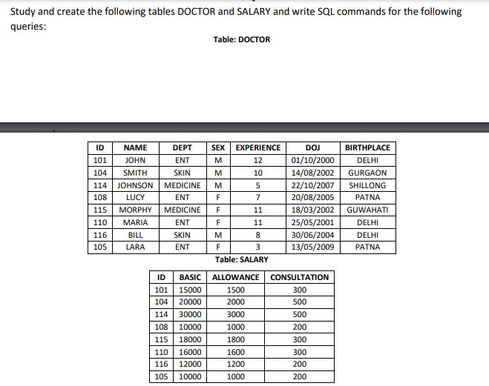

* First Create the above table with valid constraint and Structure, then write SQL queries for the following:

1. Display NAME of all doctors who are in “ENT” having more than 10 years experience from the table DOCTOR.

2. Display the minimum ALLOWANCE of female doctors.

3. Display the highest consultation fee among all male doctors.

4. Display the average salary of all doctors working in “SKIN” department using the tables DOCTOR and SALARY where salary = BASIC + ALLOWANCE

5. Display the total number of female doctors.

6. Display the details all the doctors who have joined between 1-JAN-2000 and 30-DEC-2005.

7. Display department names along with its highest salary where the number of doctors exceeds 2.

8. Display names of all those doctors whose name starts with L or M in descending order.

9. Display NAME and DEPT all those doctors whose birth place ends with I in ascending order.

10. Display name of the doctor whose experience is least in the table DOCTOR.

11. Display the content of DOCTOR table in descending order of experience.

12. Display average experience of doctors in SKIN department.

13. Display the Second highest Basic salary from the salary table.

14. Display the frequency of doctors department wise.

15. To insert a new row in the DOCTOR table with the following data: (120, ‘GEORGE’, ‘ENT’, ‘M’, 10, ‘10-MAR-2010’, ‘DELHI’)

16. To increase the BASIC of all those doctors whose CONSULTATION is more than 300 by 10%.

17. To remove Doctor LARA from DOCTOR table.

18. To add a new attribute PH_NO of type integer in the DOCTOR table.

19. To modify attribute DEPT of DOCTOR table to have new width of 25 characters.

20. To modify the value of attribute DEPT from MEDICINE to NEURO-SURGERY of the doctors having more than 10 years of experience.

**Note: Complete the all Queries in Practical Copy.**

**BIOLOGY**

1. **Prepare Investigatory Project file on the topic of your choice.**
2. **Update your Practical copy and submit for signature.**
3. **Solve all the given worksheet.**